

**Semester Two Examination 2021**

**Question/Answer Booklet**

**PHYSICAL EDUCATION**

**STUDIES UNITS 1 & 2**

Student Name: _____________________________________

Teacher’s Name: _____________________________________

Time allowed for this paper

Reading time before commencing work: Ten minutes

Working time: Two and a half hours

**Materials required/recommended for this paper**

***To be provided by the supervisor***

This Question/Answer booklet

Multiple-choice answer sheet

***To be provided by the candidate***

Standard items: pens (blue/black preferred), pencils (including coloured), sharpener,

correction fluid/tape, eraser, ruler, highlighters

Special Items: non-programmable calculators approved for use in this examination

Important note to candidates

No other items may be taken into the examination room. It is your responsibility to ensure that you do not have any unauthorised material. If you have any unauthorised material with you, hand it to the supervisor before reading any further.

**Structure of this paper**

|  |  |  |  |  |
| --- | --- | --- | --- | --- |
| Section | Number of questions available | Number of questions to be answered | Suggested working time  (minutes) | Marks available |
| Section One  Multiple-choice | 20 | 20 | 30 | 20 |
| Section Two  Short answer | 8 | 8 | 70 | 60 |
| Section Three  Extended answer | 4 | 2 | 50 | 30 |
| **Total** | | | | /110 |

# Instructions to candidates

1. The rules for the conduct of this exam have been outlined. Sitting this examination implies that you agree to abide by these rules.
2. Write your answers in the Question/Answer booklet preferably using a blue/black pen. Do not use erasable or gel pens.
3. Answer all questions according to the following instructions.

Section One: Answer **all** questions on the separate Multiple-choice Answer Sheet

provided. For each question shade the box to indicate your answer.

Use only a blue or black pen to shade the boxes. If you make a

mistake, place a cross through that square, then shade your new

answer. Do not erase or use correction fluid/tape. Marks will not be

deducted for incorrect answers. No mark will be given if more than one

answer is completed for any reason.

Section Two: Write answers to in this Question/Answer Booklet. Wherever possible, confine your answers to the line spaces provided

Section Three: Consists of four questions. You must answer two questions. Write

your answers in this Question/Answer booklet.

1. You must be careful to confine your responses to the specific questions asked and to follow any instructions that are specific to a particular question.
2. Supplementary pages for planning/continuing your answers to questions are provided at the end of this Question/Answer booklet. If you use these pages to continue an answer, indicate at the original answer where the answer is continued, i.e. give the page number.

**Section One: Multiple Choice (20 marks)**

This section has **twenty (20)** questions. Answer **all** questions on the separate Multiple-choice answer sheet provided. For each question, shade the box to indicate your answer. Use only a blue or black pen to shade the boxes. If you make a mistake, place a cross through that square, then shade your new answer. Do not erase or use correction fluid/tape. Marks will not be deducted for incorrect answers. No marks will be given if more than one answer is completed for any question.

Suggested working time: 30 minutes.

1. In athletics, a 400m race lasting approximately 60sec is fuelled by:

(a) the ATP/PC system with small contributions from the anaerobic glycolysis system

(b) the anaerobic glycolysis system with limited contribution from the aerobic energy system

(c) relatively equal contributions from the anaerobic and aerobic energy systems

(d) the aerobic energy system with small contribution from the anaerobic glycolysis system

2. Angular motion is:

(a) where all the parts of a body move through a rotational pathway, through the same angle, in different directions and at the same time

(b) where all the parts of a body move through a rotational pathway, through the same angle, in the same direction and at the same time

(c) where all the parts of a body move through a rotational pathway, through different angles, in the same direction and at the same time

(d) a combination of linear and general motion

3. Skills performed by athletes are categorised using a number of different classification systems. Bowling a ball in cricket is best classified as a:

(a) fine skill and a discrete skill

(b) motor skill and an open skill

(c) continuous skill and a closed skill

(d) gross skill and a serial skill

4. During her debut WAFL game, Lisa is given a free kick. In preparing for her kick, she quickly scans the field for a teammate to kick to, but then opts to kick for a goal. The changing of Lisa’s attentional focus would require her to move from:

(a) broad external to narrow external

(b) broad internal to narrow external

(c) narrow internal to broad external

(d) narrow external to broad internal

5. Use the table to identify the muscles labelled below.

|  |  |  |  |  |
| --- | --- | --- | --- | --- |
|  | i) | ii) | iii) | iv) |
| (a) | Pectoralis | Triceps | Quadriceps | Latissimus |
| (b) | Pectoralis | Deltoid | Adductors | Latissimus |
| (c) | Pectoralis | Deltoid | Abductors | Latissimus |
| (d) | Triceps | Deltoid | Abductors | Gluteus Maximus |

6. Complete the table below to show how the tidal volume, respiratory rate, and stroke volume change during exercise.

|  |  |  |
| --- | --- | --- |
| **Volume name** | **Value at rest** | **Change during exercise (increase, decrease, no change)** |
| Tidal volume | 500cm3 | i |
| Respiratory rate | 16 breaths per minute | ii |
| Stroke volume | 70mL | iii |

(a) i) Increase ii) decrease iii) increase

(b) i) Increase ii) increase iii) increase

(c) i) No change ii) increase iii) decrease

(d) i) No change ii) increase iii) increase

7. When referring to the summation of forces for maximum force development, which one of the following statements is incorrect?

(a) Each segment must make an optimum contribution before the next body part begins its movement

(b) As many body parts (segments) as possible should be recruited

(c) Body segments are sequenced from small to large

(d) Athletes should follow through towards the target to prevent the deceleration of the final segment.

8. During a training session, a swimming coach holds up split times on a whiteboard at the side of the pool for the athlete to see. This is an example of:

(a) proprioceptive feedback

(b) terminal feedback

(c) knowledge of performance feedback

(d) concurrent feedback

9. The optimal level of arousal varies based on the activities being performed. Which of the following statements is most correct?

(a) Fine motor skills generally require higher levels of arousal

(b) Athletes participating in activities that involve rapid decision-making benefit from high levels of arousal

(c) Athletes participating in activities requiring broad attentional focus benefit from lower levels of arousal

(d) Gross motor skills generally require lower levels of arousal

10. The most likely cause of fatigue in a 100m running sprint is:

(a) the accumulation of hydrogen ions

(b) the accumulation of lactic acid

(c) the depletion of creatine phosphate stores

(d) dehydration

11. When throwing a javelin for maximal distance, providing that all else remains constant, a taller person will:

(a) throw at the same angle

(b) throw at an increased angle

(c) throw at a reduced angle

(d) throw at 45 degrees

12. During exercise, blood flow is diverted from some organs. Which organs are likely to receive less blood flow during exercise?

(a) Heart and the kidneys

(b) Skeletal muscles and the brain

(c) Skin and the small intestine

(d) Small intestine and the kidneys

13. During a hamstring curl (pictured below), ______________ takes place at the knee joint during the lifting phase.

(a) flexion

(b) extension

(c) abduction

(d) adduction

14. The Information Processing Model is a four-stage process which describes how athletes receive information and produce a response. The input stage of the Information Processing Model refers to:

(a) gathering information about the environment

(b) organising information which has been picked up by the senses

(c) performing a skill in a changing environment

(d) receiving feedback post performance

15. A rugby player wishing to maintain balance against the force of his opponent should:

(a) lower his centre of gravity, decrease his base of support, and keep his line of gravity as close as possible to the direction of the oncoming force

(b) lower his centre of gravity, decrease his base of support, and keep his line of gravity as far as possible from the direction of the oncoming force

(c) lower his centre of gravity, increase his base of support, and keep his line of gravity as close as possible to the direction of the oncoming force

(d) lower his centre of gravity, increase his base of support, and keep his line of gravity as far as possible from the direction of the oncoming force

16. A number of sports such as boxing and horse racing require athletes to ‘make weight’ prior to their event. This often involves a period of rapid weight loss, usually achieved by deliberately dehydrating the athlete, and is linked with which health related component of fitness?

(a) Cardiorespiratory endurance

(b) Muscular strength

(c) Muscular endurance

(d) Body composition

17. The graph below shows a swimmer’s depth and rate of breathing at rest. Identify, using the data in figure 1, the name of the lung volume labelled A.

(a) Minute Ventilation

(b) Respiratory rate

(c) Vital capacity

(d) Tidal volume

18. Which of the following provides the best example of an athlete utilising proprioceptive cues to improve their performance?

(a) A tennis player changing her shot last minute after seeing the opponent lose their footing.

(b) A snowboarder adjusting their body position and plantar flexing their ankles during a turn to avoid falling.

(c) A Formula One driver taking a wide line into a corner after seeing dirt and debris on the inside of the upcoming corner.

(d) A basketball player making a no look pass after hearing a teammates call.

19. The following table contains part of a weights training program that a prospective soccer player was using to improve his _________________ in his arms and legs prior to the start of the soccer season.

|  |  |  |  |
| --- | --- | --- | --- |
| **Exercise** | **Sets** | **Repetitions** | **Resistance** |
| Seated leg press | 4 | 4-6 | 85% 1 repetition maximum |
| Military press | 5 | 3-5 | 90% 1 repetition maximum |
| Bicep curl | 4 | 4-6 | 85% 1 repetition maximum |
| Leg curl | 4 | 4-6 | 85% 1 repetition maximum |
| Leg extension | 6 | 3-5 | 90% 1 repetition maximum |
| Triceps extension | 5 | 3-5 | 90% 1 repetition maximum |

(a) muscular power

(b) muscular endurance

(c) muscular strength

(d) cardiorespiratory endurance

20. Use the table to identify the bones on the skeleton below.

ii

iv

iii

i

|  |  |  |  |  |
| --- | --- | --- | --- | --- |
|  | i) | ii) | iii) | iv) |
| (a) | Ulna | Radius | Tibia | Fibula |
| (b) | Radius | Ulna | Fibula | Tibia |
| (c) | Radius | Ulna | Tibia | Fibula |
| (d) | Ulna | Radius | Fibula | Tibia |

**End of Section One**

**Section Two: Short answer (60 marks)**

This section has **eight (8)** questions. Answer **all** questions. Write your answers in the spaces provided. Use a blue or black pen (**not** pencil) for this section.

Supplementary pages for the use of planning/continuing your answer to a question have been provided at the end of this Question/Answer booklet. If you use these pages to continue an answer, indicate at the original answer where the answer is continued, i.e. give the page number.

Suggested working time: 70 minutes.

________________________________________________________________________

**Question 21 (7 marks)**

Earlier this year, former Aquinas College student Logan McDonald made his AFL debut for the Sydney Swans against last year’s preliminary finalist, the Brisbane Lions.

Prior to the start of the game, Logan had to ensure he was in the ideal performance state to be able to perform at his optimal level.

(a) Identify and explain the hypothesis that outlines the relationship between arousal and performance.

(3 marks)

(b) Identify which state of arousal Logan was likely to be in for the start of the match.

(1 mark)

(c) Explain **three** factors that have an influence on the optimal level of arousal of an athlete.

(3 marks)

**Question 22 (6 marks)**

Complete the table below identifying the key properties for the three types of muscle fibres.

|  |  |  |  |
| --- | --- | --- | --- |
| Property | Muscle fibre types | | |
| Type l | Type lla | Type llb |
| Fibre diameter |  |  |  |
| Force production |  |  |  |
| Contractile speed |  |  |  |
| Major fuel source |  |  |  |
| Mitochondrial density |  |  |  |
| Activity used for |  |  |  |

**Question 23 (9 marks)**

(a) Outline **two** structural differences that exist between arteries and veins.

(2 marks)

(b) The capillaries that surround muscles are crucial to the exchange of gases, fuels and wastes. Discuss how a concentration gradient allows for effective gas exchange to take place at the capillary/muscle interface.

(2 marks)

(c) Ben Simmons will often take a deep breath through his nose before focusing on shooting a free throw shot at the line. Explain the mechanics of the diaphragm and the intercostal muscles during inhalation and how air is able to enter the lungs.

(3 marks)

(d) During lockdown earlier in the year, it was mandated that people wear masks whenever they left their home, except to exercise. Why would wearing a mask make exercising more difficult?

(2 marks)

**Question 24 (5 marks)**

A Year 11 Physical Education Studies student completes the 12-minute run test. She runs 7 ½ laps of a 400m running track with her start and finish points identified on the image below. Use this information to answer the following questions.

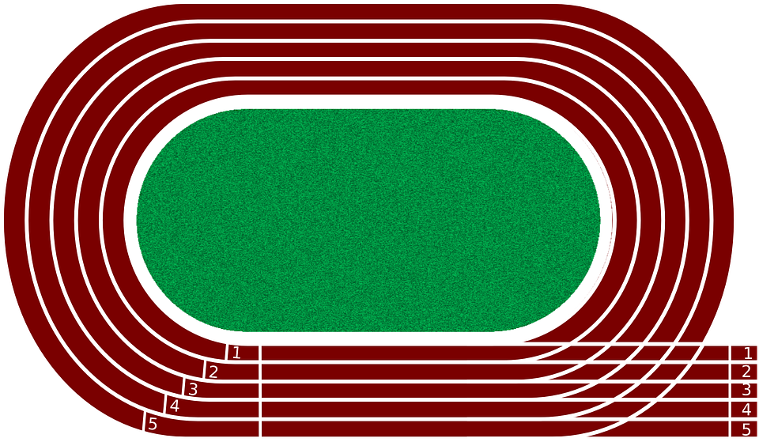

**Finish**

**150mm**

**Start**

(a) What was her displacement at the end of the 12 minutes?

(1 mark)

(b) Would her displacement differ to her distance? Justify your response

(2 marks)

(c) How would you calculate her average speed?

(1 mark)

(d) How would you calculate her average velocity?

(1 mark)

**Question 25 (8 marks)**

The table belowshows suggested target heart rate zones for various age groups.

|  |  |  |  |  |  |  |  |  |  |
| --- | --- | --- | --- | --- | --- | --- | --- | --- | --- |
| Percentage of Maximum Heart Rate | Target Heart Rate Zones (Beats per minute) | | | | | | | | |
| 95% | 200 | 190 | 181 | 171 | 162 | 152 | 143 | 133 |
| 85% | 179 | 170 | 162 | 153 | 145 | 136 | 128 | 119 |
| 75% | 158 | 150 | 143 | 135 | 128 | 120 | 113 | 105 |
| 65% | 137 | 130 | 124 | 117 | 111 | 104 | 98 | 91 |
| 55% | 116 | 110 | 105 | 99 | 94 | 88 | 83 | 77 |
| **Age** | **10** | **20** | **30** | **40** | **50** | **60** | **70** | **80** |

(a) Using the table, state the suggested heart rate values that a 40-year-old should work between to ensure they are in the correct target zone to improve their cardiorespiratory endurance.

(1 mark)

(b) Explain why the suggested target zone for a 20-year-old is different to that suggested for a 40-year-old.

(3 marks)

(c) Identify and explain **two** training methods an athlete could use to improve their cardiorespiratory endurance.

(4 marks)

**Question 26 (8 marks)**

The arrow directions in the diagrams below show two types of isotonic muscle contractions.

(a) Which diagram shows a concentric contraction? Justify your answer.

(2 marks)

(b) Which diagram shows an eccentric contraction? Justify your answer.

(2 marks)

(c) Using diagram A, identify the following:

(4 marks)

i) Agonist: __________________________________________________________

ii) Origin of agonist ___________________________________________________

iii) Antagonist: _______________________________________________________

iv) Insertion of Antagonist: _____________________________________________

**Question 27 (8 marks)**

In sumo wrestling, two people who are wearing nothing but a mawashi (loincloth), face each other in a dohyo (circular ring) and push, grapple, and try to throw each other. The one who forces their opponent to the ground or pushes them out of the ring is considered the winner.

(a) Throughout a sumo wrestling bout, the athletes will position their body in a variety of ways to improve their balance and stability. Outline **three** strategies a wrestler might use to make them more stable during a sumo bout.

(3 marks)

(b)Define Momentum and, applying this with your knowledge of Newton’s 2nd Law, explain how a smaller wrestler might be able to push their larger opponent out of the ring.

(3 marks)

(c)At the 2012 London Olympic Games, new starting blocks were introduced, as shown in the image below (lanes 8 and 9). By comparison with previous blocks (lane 6 and 7), the new blocks have a raised lip at the rear.

Using Newton's 3rd Law, explain how changes to starting blocks have resulted in quicker start times in swimming.

(2 marks)

**Question 28 (9 marks)**

Fitts and Posner proposed the skill learning continuum occurs across three (3) progressive stages:

1. The Cognitive Phase

2. The Associative Stage

3. The Autonomous Stage

Each stage is characterised by the individual demonstrating different attributes. Complete the table below to highlight these.

|  |  |  |  |
| --- | --- | --- | --- |
|  | **Cognitive Stage** | **Associative Stage** | **Autonomous Stage** |
| Type of feedback | Extrinsic augmented |  |  |
| Cue recognition |  | Some relevant cue recognition |  |
| Consistency of performance |  |  | High levels of consistency/low levels of variability in performance |
| Size and frequency of errors |  |  |  |

**End of Section Two**

**Section Three: Extended answers 30% (30 marks)**

This section contains **four (4)** questions. You must answer **two (2)** questions. Write your answer in the spaces provided.

Supplementary pages for the use of planning/continuing your answer to a question have been provided at the end of this Question/Answer booklet. If you use these pages to continue an answer, indicate at the original answer where the answer is continued, i.e. give the page number.

Suggested working time: 50 minutes.

**Question 29 (15 marks)**

In 2019 Kenyan marathoner Eliud Kipchoge became the first human to run a marathon in under two hours, covering the 42km distance in 1 hour, 59 minutes and 40 seconds. The run, organised specifically for Kipchoge to break the two-hour marathon barrier, and featured an electric pacer car that shot a laser beam to mark the best position on the road.

(a) A key component of the event was Kipchoge’s nutritional plan. Discuss what this nutritional plan would have involved before and during the event to ensure he had sufficient nutrients and energy to fuel the race.

(9 marks)

(b) Discuss the term ‘energy system interplay’ as it relates to an athletics sprint event like the 400m (approximately 50 sec duration).

(6 marks)

**Question 30. (15 marks)**

Pictured below are three (3) different sporting activities.

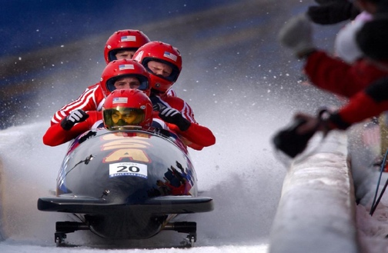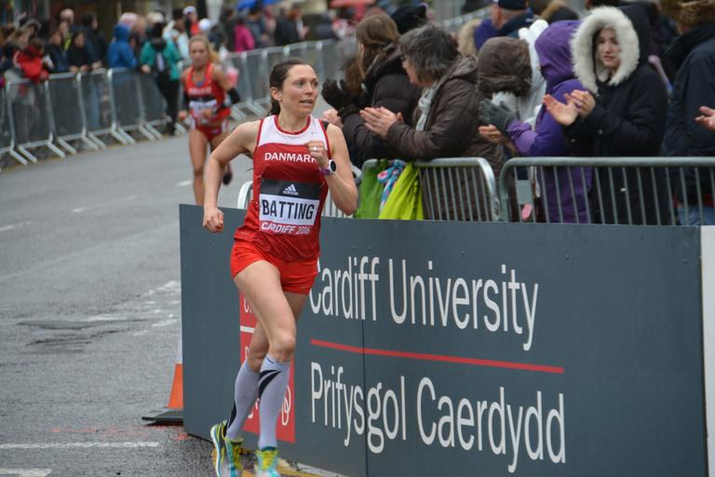

Image A – Bobsleigh Image B – Runner Image C – gymnast on horizontal bar

(a) Identify and describe **three** different types of motion. Include an example of each type of motion from the pictures above (note – each image can only be used once)

(9 marks)

The bobsleigh is a winter sport that involves making timed runs down twisting, iced tracks in a gravity-powered sleigh. The start is initiated by the push from the gate, with athletes running and pushing as hard as possible over approximately 50m distance, with the crew members loading into the sled in a synchronised sequence.

The marathon is a long-distance race completed over 42km and takes just over 2hrs to complete.

The horizontal bar requires gymnasts to perform giant swings and spectacular aerial releases and dismounts that often include multiple flips or twists and, in some cases, airborne travel over the bar. It requires great strength, power, and flexibility to complete the event.

(b) Identify **one** training method that could be recommended for an athlete in each event and justify your response. You must use a different training method for each athlete.

(6 marks)

**Question 31 (15 marks)**

The Information Processing Model is based on the central nervous system that controls the body. The model describes separate cognitive stages involving perception, decision-making and response execution to enable an athlete’s decision-making to occur prior to any action­.

(a) Identify and describe the **four** phases of the Information Processing Model.

(8 marks)

(b) Describe the key differences between the performance of a skilled and novice athlete in each of the phases identified in part (a).

(7 marks)

**Question 32. (15 marks)**

(a) Skeletal muscle response is caused by different functional characteristics. Describe these **four** characteristics and provide an example of each.

(8 marks)

(b) An athlete’s concentration can be influenced by three factors: age, skill level and the type of activity. Define the term concentration and describe how each of these factors impact an individual’s concentration. Additionally, for each factor, suggest **one** strategy a coach who is training an Under 9’s soccer team could use to improve the concentration of the players.

(7 marks)

**End of Paper**

Supplementary page

Question number:___________